**Mobile Development**

We are specialized in business directory development and data crawling and completed many successful jobs so far. We also provide web based different devices compatible mobile application which supports devices like iPhone, android, symbiont etc.

1. **Business App:**

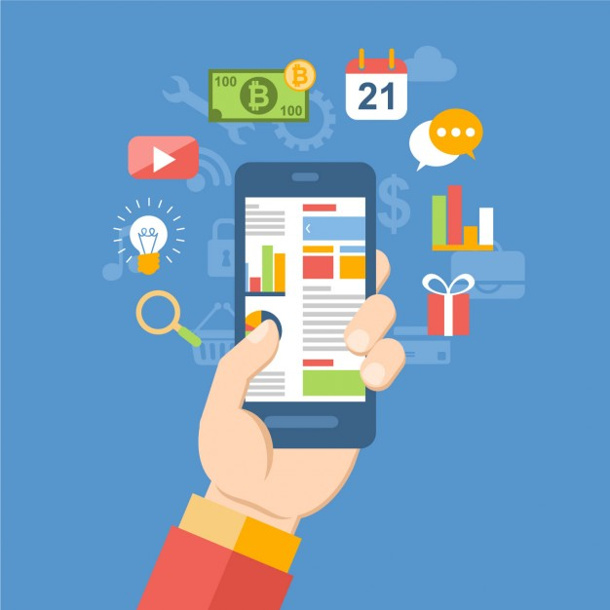

Are you having successful meetings? How do you know? **This** is an intuitive and elegant application for iPads that makes it easy to gather up and “map” (thus the name) the information you need for truly successful meetings. This application tracks the role and the stance (opinion) of every participant in a meeting, and makes it easy to create action items or next steps and automatically schedule the actions for follow up. A related application is integrated with Sales Force and is optimized to serve as a strategic weapon for closing new sales.



1. **Construction App:**

A half million construction professionals can’t be wrong. That’s the estimated number of people using the app, which allows the transfer of maintenance logs, daily reports, project estimates and time sheets between company headquarters and construction sites. It also gives salespeople and estimators the ability to create on-site estimates for construction and repair projects.

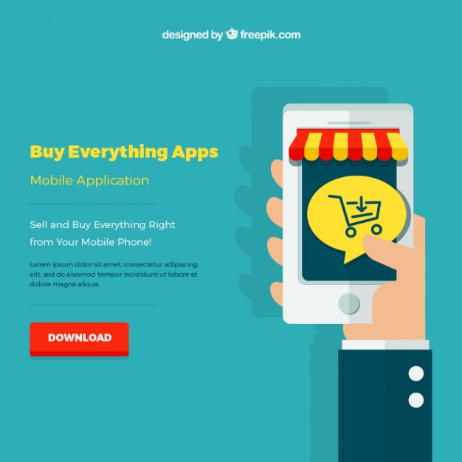

1. **Mobile Commerce**

E-commerce App offers an Instagram-like photo feed of products to purchase, with a curated community of brands that includes luxury labels and emerging designers. Explore collections curated by influencers and editors. This App has no shopping cart. After users have initially filled out credit card and shipping info, they just swipe beneath an item to buy it. And after users like an item, the seller can send them push notifications.

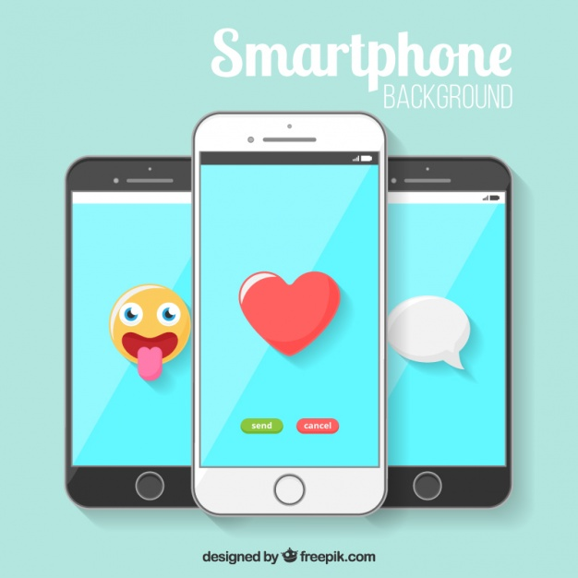

1. **Mobile Emoticons:**

Emoji Keyboard – Emoticons is a simple looking keyboard with some cute looking emoji and options customize color, font and layout. There are only two steps to go through and you get access to over 3000 smiley, emoticons, emoji, sticker and text face. It’s quite user friendly and can look for matching emoji for your words using the smart emoji prediction feature. However, free users don’t get to customize a lot and features like changing keyboard wallpaper, choosing always capital letter option and white theme are only available for Pro users. Moreover, it requires re-enabling after updating which can be a problem for some users. You can use emoji in email, SMS, chat and inside social apps.

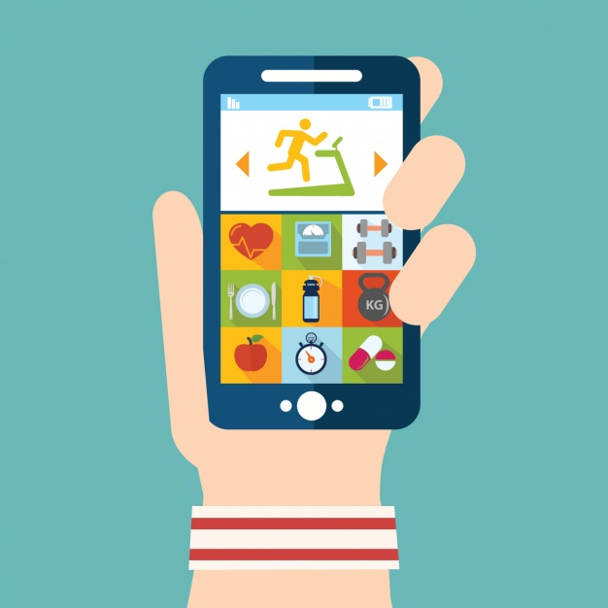

1. **Fitness App:**

If you want real hard stats about your workouts, accelerometers and GPS aren't enough. You need a heart rate monitor...and an app that can access the information it collects. One option is the fitness app for iPhone and Android. You can pair it with any supported heart rate monitor to track your runs, bicycle rides, and other workouts. App records heart rate, of course, but also distance, time, and pace. All the components needed to track heart rate can add up, so plan to spend somewhere to get full use of this app.

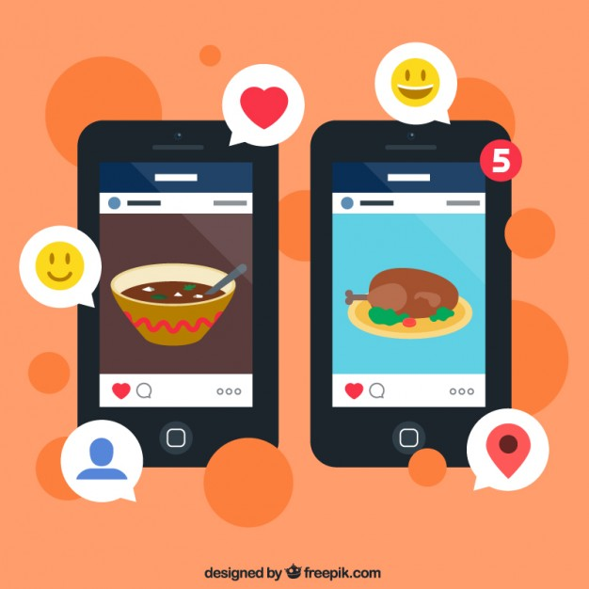

1. **Food App:**

Food App is the last in this takeout/delivery category and covers numerous restaurants in varied cities.

If you are just hunkering for pizza, probably the top to-go food item in the State, then just search for Dominos or Pizza Hut. They both have useful apps.



1. **Location App:**

Location based App was an innovator in location-aware apps, helping popularize the idea of "checking in" to locations through your mobile device. The App has since split its app into two parts: Main app continued on as a location-aware smart search tool focusing on discovery of nearby locations, events, restaurants and shops, while other app was released for those addicted to checking in and location sharing with friends. Users enter their favorite foods and activities, and location app helps them find nearby places that fit the bill. Other app helps you meet up with your friends by broadcasting your location to your Location app contacts, letting you quickly see who's nearby, and where. Check in to a place, post a status message that you're looking to hang out and get in touch with your friends.

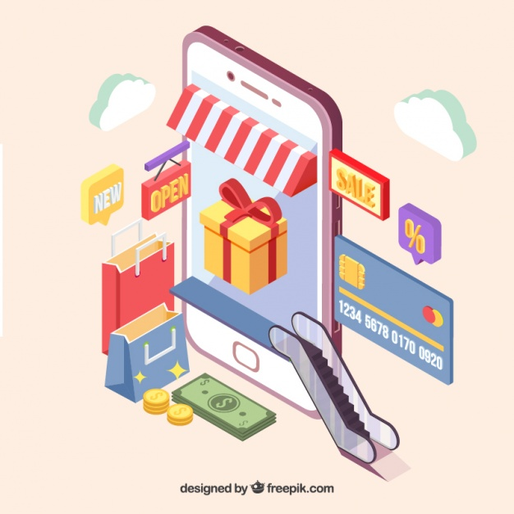

1. **Shopping app**

This is a unique shopping app that lets you shop for various things and get savings when you buy certain “smart items” together. It has a ton of stuff for sale so it shouldn’t be hard to find what you’re looking for. You’ll also get free shipping once your order amount gets high enough and you’ll also get Android Pay support, one-click re-ordering, and some odd, but unique tactics like giving you the opportunity to waive return rights in order to save a bit more money. It looks like fun and it’s worth a shot.

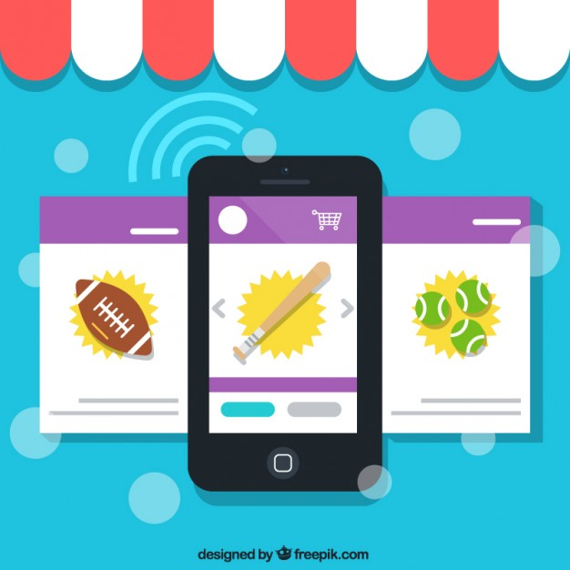

1. **Sports App**

The Sports App (Android, iOS) shines in delivering up-to-the-second game updates and statistics, as well as breaking sports news. An event calendar lets you easily look up upcoming games, statistics for past matches, as well as the latest scores and most important plays. Matches include detailed statistical breakdowns to warm the hearts of stat junkies, as well as play-by-play breakdowns. The app allows users to follow teams and individual players, giving you notifications of related news or big plays. Social features make stories, stats and game summaries easy to share with your friends and followers.

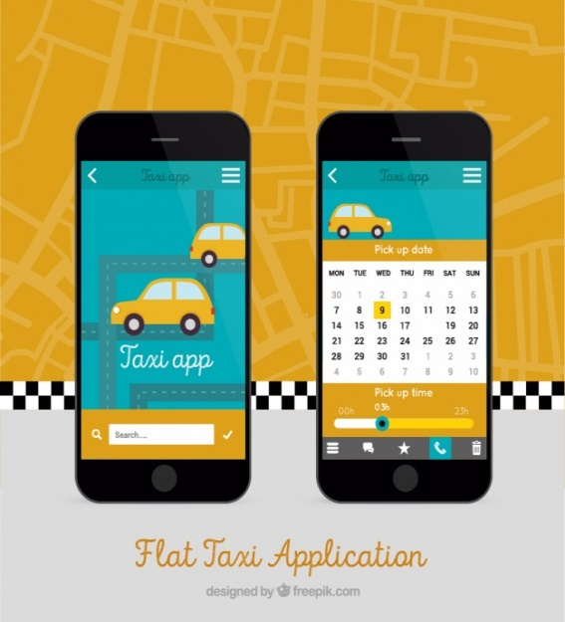

1. **Taxi App**

Taxi App, available for iPhone and Android, is a lot like Uber, but arguably even simpler to use. Once you’ve got an account you simply select a pickup location and select a car, allowing you to request a taxi in literally just two taps.

There is a little more to it if you want of course, with the ability to track your car on a map, but there’s no need to as the app will alert you when your driver arrives anyway.

Like Uber you also get fare quotes and payment is handled automatically. That’s a good start given they’re four of the busiest cities.

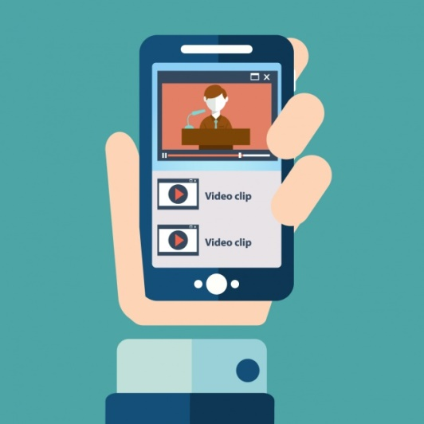

1. **Video players**

Video Player is designed to play iPhone formats like 3gp, h263, and h264 baseline profile. It also claims to play some baseline MP4 files, but not all (it had no problem with mine). Other files will need converting, but the developer page does point you in the direction of some free software that will do the job nicely. Act 1 is not only a tiny 500KB, but it can also be moved to your SD card.

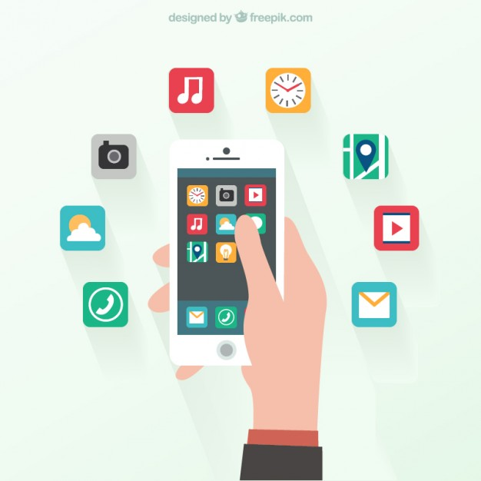

1. **Weather App**

The Weather App has been a long time authority on weather and on Android it’s no different. That said, it actually is a pretty decent weather app with all the information you could need including forecasts, alerts, current weather, radar, and smaller stuff like wind forecast, pollen, and even Weather Channel videos so you can keep up on the latest weather news. There is a mechanic called points that do not really do much, but you can disable that in the settings to make the app run a bit smoother.